Assume that the error term ϵ in the linear regression model is independent of x, and is normally distributed, with zero mean and constant variance. We can decide whether there is any significant relationship between x and y by testing the null hypothesis that β = 0.

Problem

Decide whether there is a significant relationship between the variables in the linear regression model of the data set Salary_Data at .05 significance level.

#help(summary.lm)

regressor = lm(formula = Salary ~ YearsExperience,

data = Salary_Data)

#Then we print out the F-statistics of the significance test with the summary function.

summary(regressor)

regressor = lm(formula = Salary ~ YearsExperience,

data = Salary_Data)

summary(eruption.lm)$r.squared

#Then we print out the F-statistics of the significance test with the summary function.

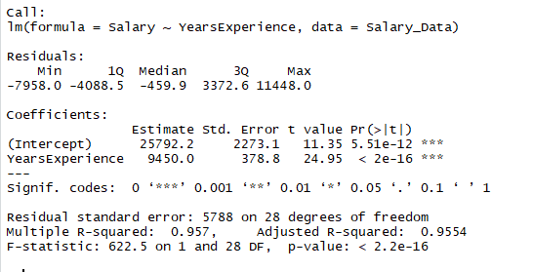

summary(regressor) As the p-value is much less than 0.05, we reject the null hypothesis that *β*= 0. Hence there is a significant relationship between the variables in the linear regression model of the data set Salary_Data.